מיני פרויקט  
בסיסי נתונים

דו"ח מסכם – חלק א

בנושא

יחידת יהלום (צה"ל)



**מגישים:  
יואב בביוף  
אבישי שחור**

תוכן

תיאור הארגון 3

תרשים ה-ERD 4

תרשים DSD 5

פירוט הישויות והקשרים 6

נרמול הסכמה 8

פקודות create table 9

הפעלת desc 11

פקודות drop tables 13

פקודות select all 14

יצירת מידע 15

שיטה 1 – Mockaroo 15

שיטה 2 – python code 22

שיטה 3 – data generator (PLSQL developer) 32

גיבוי נתונים 37

שחזור נתונים מגיבוי 38

# תיאור הארגון

הארגון הוא היחידה הצבאית המובחרת **יחידה הנדסית למשימות מיוחדות**, בראשי תיבות: **יהל"ם** (נהגה: **יהלום**). היחידה היא יחידה קרבית מובחרת וככזו היא יוצאת למבצעים מיוחדים, מוקצה לה רב צבאי מיוחד, וכל חייל בה חבר בצוות מסויים.

**חברי היחידה:**

היחידה מורכבת מהיחידה הבסיסית **solider (חייל)**, כאשר ישנם חיילים עם תפקידים מיוחדים.

* **Solider (חייל):**היחידה הבסיסית של הארגון, הוא האדם ממנו מורכבים צוותים והיוצא למשימות, **רבנים צבאיים (military Rabbi)**, **מפקדים (commander)** וכן **רופאים צבאיים (combat medic)** הם גם חיילים.  
  לכל **חייל** יש מספר מזהה (id) המזהה אותו באופן חד חד ערכי, ותכונות נוספות של חייל כגון תאריך לידה, שם, דת ודרגה. כל חייל הוא חייל ב-(solider in) 0 או יותר **צוותים** **(team)** אשר בכל אחד מהם יש לו תפקיד מסוים (responsibility).
* **רב צבאי (military Rabbi):**  
  **חייל** האחראי על הצביון הדתי של חבריה היהודיים של היחידה, בנוסף למאפיינים הרגילים של חייל יש לו גם עדה (ethnicity), האם הוא דרשן (preacher), האם הוא פייטן (payytan), מגזר (sector) והאם הוא מוסמך לרבנות (certified Rabbi).
* **רופא צבאי (combat medic):**

**חייל** האחראי על שמירת הבריאות של חבריו ל**צוות**, הוא המטפל בהם במבצעים מיוחדים (אם הוא נמצא בהם) ואחראי לבריאותם. נוסף למאפיינים הרגילים של חייל יש לו מאפיין של הסמכה (qualification) המתארת את הפעולות הרפיאות אותן הוא מוסמך לעשות, והכשרה (in training), המתארת האם הוא בתקופת הכשרה. כל **רופא צבאי** גם יכול **להשתתף (take part)** ב**מבצע** צבאי.

* **מפקד (commander):  
  חייל** **המפקד על (commands on)** **צוות** ואולי גם **מפקד על (commands on)** **מבְצָע**, כאשר אז הוא יכול לקחת חלק בקרב (active in field), או לא.  
  נוסף למאפיינים הרגילים של חייל יש לו כינוי (nickname) אופציונלי.

**קבוצות ביחידה:**

ביחידה ישנן קבוצות מיוחדות המאגדת חברי יחידה למטרה משותפת.

* **צוות (team):**היחידה הבסיסית המאגדת חברי צוות. לכל צוות בהכרח יש מפקד ה**מפקד על (commands on)** ה**צוות**. כל צוות גם **מבַצֶע (conducts)** **מבְצָע**. צוות מסוים מזוהה על פי מספר הצוות (team number).
* **מבְצָע (operation):**  
  ביצוע צבאי המממש את היכולות אותם סיגלו לעצמם **החיילים**, בכל מבצע יכולים להשתתף כמה **צוותים**, ויש לו בהכרח **רופא צבאי** אחד הדואג לחיילים המשתתפים בו ו**מפקד** אחד המפקד עליהם. מבצע מזוהה לפי מזהה המבצע (operation id), ויש לו תכונות נוספות כגון תאריך המבצע ומיקומו.

# תרשים ה-ERD

# תרשים DSD

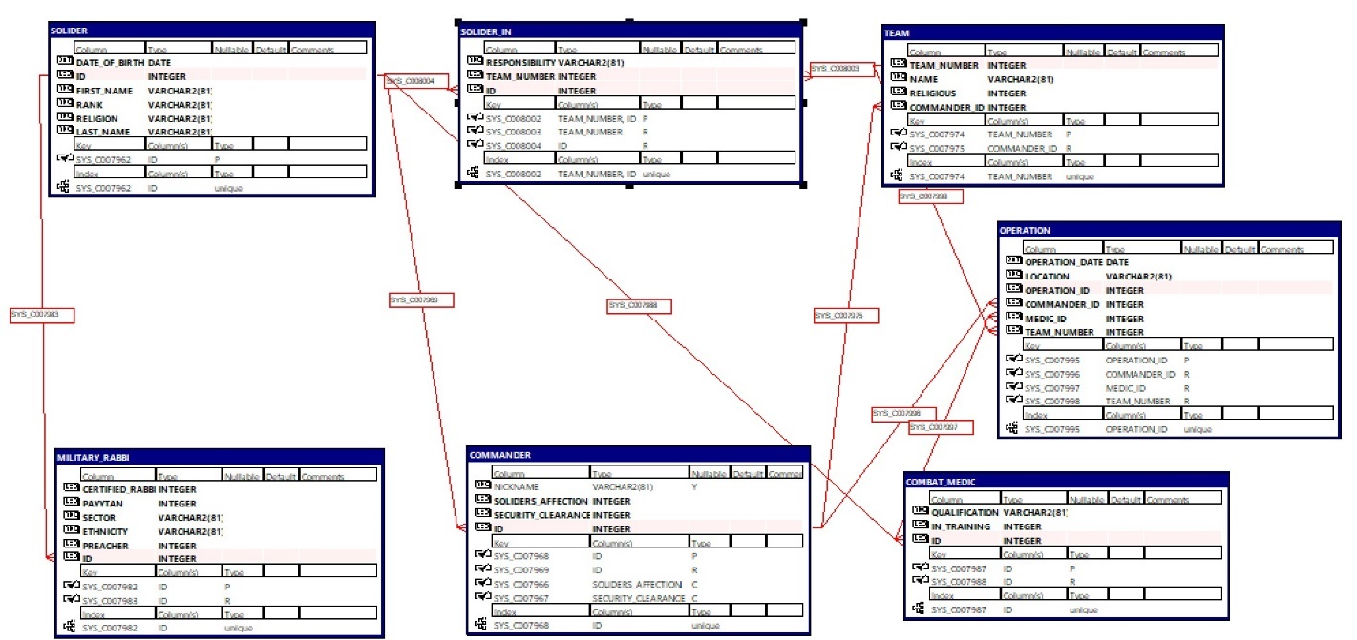

# פירוט הישויות והקשרים

חייל – Solider

|  |  |
| --- | --- |
|  |  |
| Id | מזהה |
| Date of birth | תאריך לידה |
| First name | שם פרטי |
| Rank | דרגה |
| Religion | דת |
| Last name | שם משפחה |

מפקד – commander

|  |  |
| --- | --- |
|  |  |
| Id (fk) | מזהה |
| Nickname (o) | כינוי |
| Solider affection | נערצות המפקד (ע"י החיילים) |
| First name | סיווג בטחוני |
| Rank | מספר צוות |

רב צבאי – military rabbi

|  |  |
| --- | --- |
|  |  |
| Id (fk) | מזהה |
| Certified rabbi | האם הוא רב מוסמך |
| payytan | האם הרב פייטן |
| sector | מגזר |
| ethnicity | עדה |
| preacher | האם הרב דרשן |

חובש קרבי – combat medic

|  |  |
| --- | --- |
|  |  |
| Id (fk) | מזהה |
| Qualification | תחום התמחות |
| In Training | האם עדיין בהכשרה |

צוות – team

|  |  |
| --- | --- |
|  |  |
| Team number | מספר צוות |
| Commander Id (fk) | מזהה המפקד |
| Name | שם הצוות |
| Religious | האם הצוות הינו צוות דתי |

מבצע צבאי – Operation

|  |  |
| --- | --- |
|  |  |
| Operation ID | מזהה מבצע |
| Date | תאריך בו בוצע המבצע |
| Commander Id (fk) | מזהה מפקד |
| medic Id (fk) | מזהה חובש קרבי |
| Location | מיקום המבצע |
| Team Number (fk) | מספר צוות בו חבר החייל |

חייל בצוות – solider in

|  |  |
| --- | --- |
|  |  |
| ID (fk) | מזהה החייל |
| Team number (fk) | מספר הצוות בו החייל נמצא |
| responsibility | תפקיד החייל בצוות |

# נרמול הסכמה

הסכמה מנורמלת לפי 3NF, שכן לכל הטבלאות שלנו, כל תכונה תלויה בכל התכונות שבמפתח, ורק בהן.

# פקודות create table

*-- Create table for soldiers*

CREATE TABLE solider

(

date_of_birth DATE NOT NULL,

id INT NOT NULL,

first_name VARCHAR(81) NOT NULL,

rank VARCHAR(81) NOT NULL,

religion VARCHAR(81) NOT NULL,

last_name VARCHAR(81) NOT NULL,

PRIMARY KEY (id)

);

*-- Create table for commanders*

CREATE TABLE commander

(

nickname VARCHAR(81),

soliders_affection INT NOT NULL, CHECK (soliders_affection >= 1 AND soliders_affection <= 10),

security_clearance INT NOT NULL, CHECK (security_clearance >= 1 AND security_clearance <= 5),

id INT NOT NULL,

PRIMARY KEY (id),

FOREIGN KEY (id) REFERENCES solider(id)

);

*-- Create table for teams*

CREATE TABLE team

(

team_number INT NOT NULL,

name VARCHAR(81) NOT NULL,

religious INT NOT NULL,

commander_id INT NOT NULL,

PRIMARY KEY (team_number),

FOREIGN KEY (commander_id) REFERENCES commander(id)

);

*-- Create table for military rabbis*

CREATE TABLE military_Rabbi

(

certified_Rabbi INT NOT NULL,

Payytan INT NOT NULL,

sector VARCHAR(81) NOT NULL,

ethnicity VARCHAR(81) NOT NULL,

preacher INT NOT NULL,

id INT NOT NULL,

PRIMARY KEY (id),

FOREIGN KEY (id) REFERENCES solider(id)

);

*-- Create table for combat medics*

CREATE TABLE combat_medic

(

qualification VARCHAR(81) NOT NULL,

in_training INT NOT NULL,

id INT NOT NULL,

PRIMARY KEY (id),

FOREIGN KEY (id) REFERENCES solider(id)

);

*-- Create table for military operations*

CREATE TABLE operation

(

operation_date DATE NOT NULL,

location VARCHAR(81) NOT NULL,

operation_id INT NOT NULL,

commander_id INT NOT NULL,

medic_id INT NOT NULL,

team_number INT NOT NULL,

PRIMARY KEY (operation_id),

FOREIGN KEY (commander_id) REFERENCES commander(id),

FOREIGN KEY (medic_id) REFERENCES combat_medic(id),

FOREIGN KEY (team_number) REFERENCES team(team_number)

);

*-- create table for solider-team connection*

CREATE TABLE solider_in

(

responsibility VARCHAR(81) NOT NULL,

team_number INT NOT NULL,

id INT NOT NULL,

PRIMARY KEY (team_number, id),

FOREIGN KEY (team_number) REFERENCES team(team_number),

FOREIGN KEY (id) REFERENCES solider(id)

);

# הפעלת desc

נבדוק שהטבלאות נוצרו:

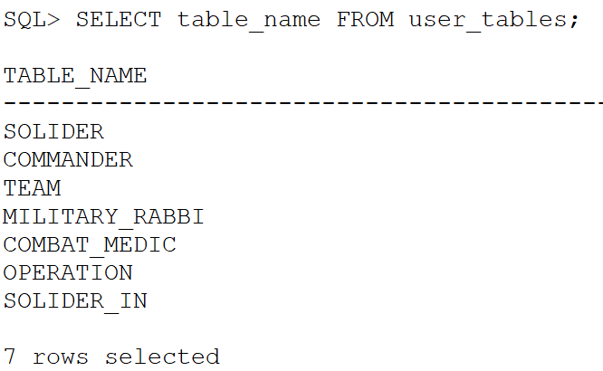

וכן הן נוצרו.  
נפעיל את פקודת DESC[RIBE] על מנת לוודא שהטבלאות נוצרו כראוי:

ואכן כל הטבלאות נוצרו כנדרש.

# פקודות drop tables

*-- Drop the combat_medic table*

DROP TABLE combat_medic CASCADE CONSTRAINTS;

*-- Drop the military_rabbi table*

DROP TABLE military_rabbi CASCADE CONSTRAINTS;

*-- Drop the operation table*

DROP TABLE operation CASCADE CONSTRAINTS;

*-- Drop the team table*

DROP TABLE team CASCADE CONSTRAINTS;

*-- Drop the commander table*

DROP TABLE commander CASCADE CONSTRAINTS;

*-- Drop the solider table*

DROP TABLE solider CASCADE CONSTRAINTS;

*-- Drop the solider-in table*

DROP TABLE solider_in CASCADE CONSTRAINTS;

# פקודות select all

*-- Select all records from the solider table*

SELECT * FROM solider;

*-- Select all records from the commander table*

SELECT * FROM commander;

*-- Select all records from the team table*

SELECT * FROM team;

*-- Select all records from the military_Rabbi table*

SELECT * FROM military_Rabbi;

*-- Select all records from the combat_medic table*

SELECT * FROM combat_medic;

*-- Select all records from the operation table*

SELECT * FROM operation;

*-- Select all records from the solider-n table*

SELECT * FROM solider_in;

# יצירת מידע

## שיטה 1 – Mockaroo

Military Rabii:  
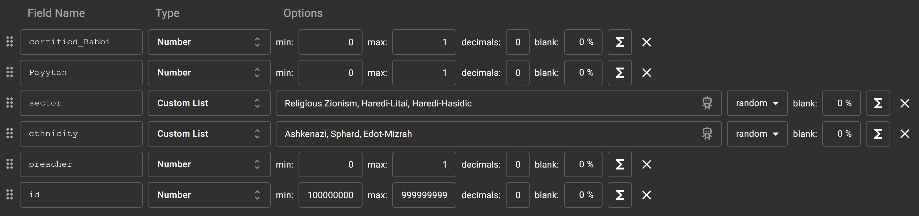

Combat Medic:

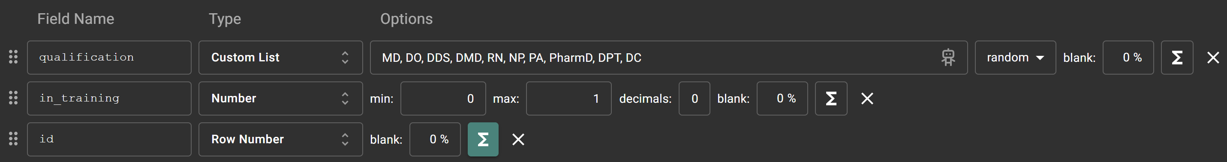

Commander:

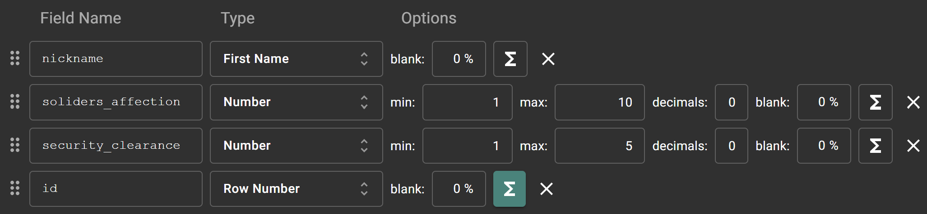

Team:

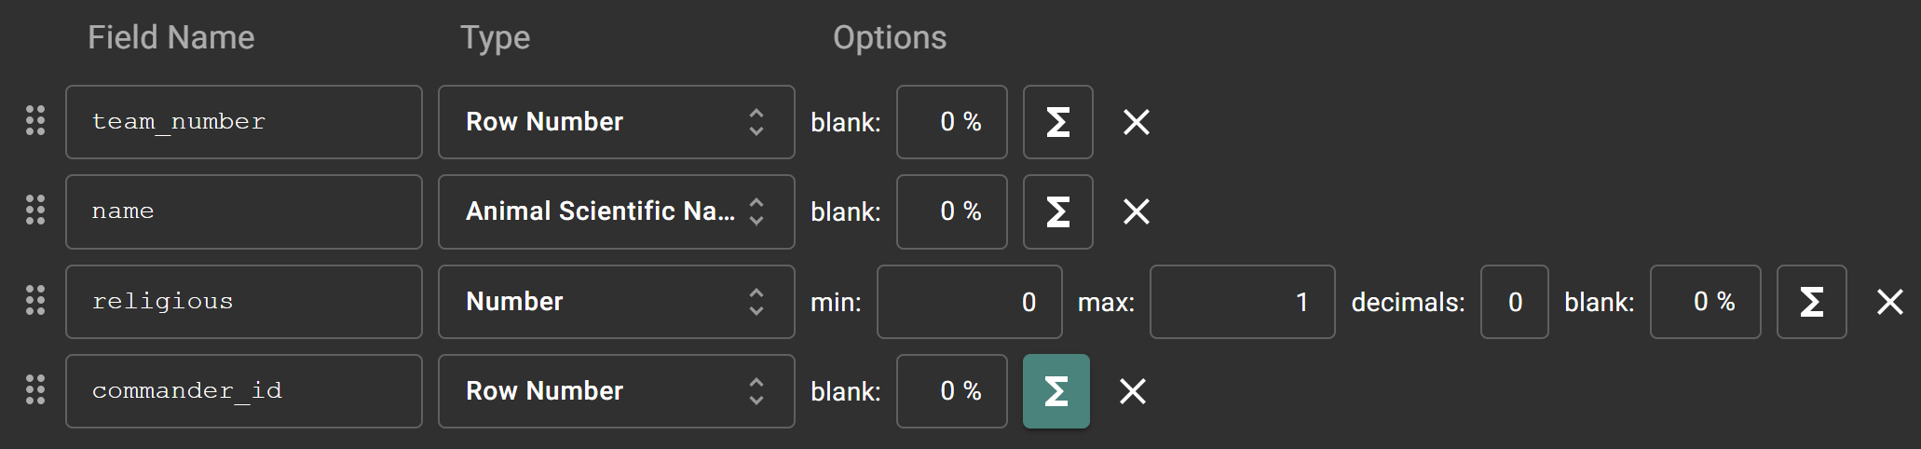

Operation:

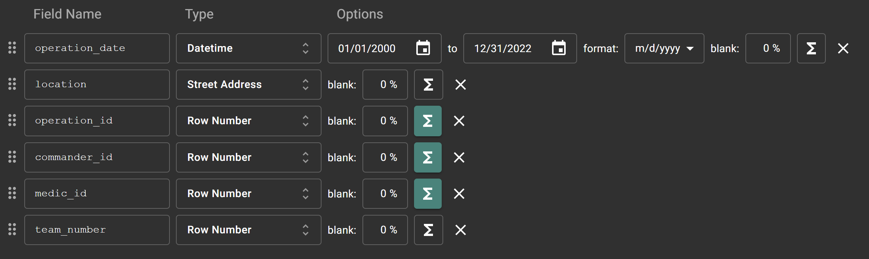

Solider:

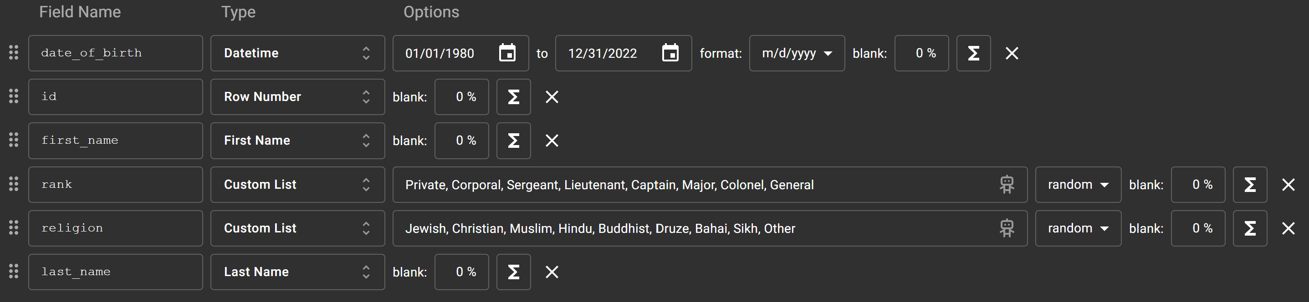

Solider-In:

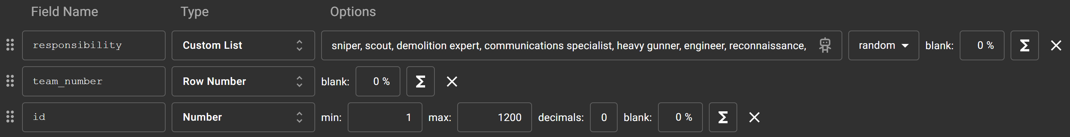

Generated SQL code can be found in the GitHub directory.

Here is a sample of the generated SQL code and it’s result:

INSERT INTO solider (date_of_birth,id,first_name,rank,religion,last_name) VALUES(DATE '1998-02-09',1,'Madelene','Corporal','Druze','McDougal');

INSERT INTO solider (date_of_birth,id,first_name,rank,religion,last_name) VALUES(DATE '2011-3-4',2,'Kerwin','Lieutenant','Zoroastrian','Cordingly');

INSERT INTO solider (date_of_birth,id,first_name,rank,religion,last_name) VALUES(DATE '1997-4-6',3,'Blakeley','Lieutenant','Muslim','Alecock');

INSERT INTO solider (date_of_birth,id,first_name,rank,religion,last_name) VALUES(DATE '2003-2-02',4,'Domingo','General','Jewish','Wildgoose');

INSERT INTO solider (date_of_birth,id,first_name,rank,religion,last_name) VALUES(DATE '1998-9-06',5,'Lori','Captain','Zoroastrian','Slorance');

INSERT INTO solider (date_of_birth,id,first_name,rank,religion,last_name) VALUES(DATE '1986-9-9',6,'Trixie','Sergeant','Christian','Pettiward');

INSERT INTO solider (date_of_birth,id,first_name,rank,religion,last_name) VALUES(DATE '2015-6-05',7,'Paco','Colonel','Zoroastrian','Campelli');

INSERT INTO solider (date_of_birth,id,first_name,rank,religion,last_name) VALUES(DATE '1985-1-01',8,'Rochelle','Colonel','Jewish','Shotter');

INSERT INTO solider (date_of_birth,id,first_name,rank,religion,last_name) VALUES(DATE '1999-02-10',9,'Kile','Private','Hindu','Bebis');

INSERT INTO solider (date_of_birth,id,first_name,rank,religion,last_name) VALUES(DATE '2008-11-11',10,'Hodge','Private','Hindu','Upton');

INSERT INTO solider (date_of_birth,id,first_name,rank,religion,last_name) VALUES(DATE '1989-06-08',401,'Fallon','Lieutenant','Sikh','Mullard');

INSERT INTO solider (date_of_birth,id,first_name,rank,religion,last_name) VALUES(DATE '2009-07-03',402,'Ed','Sergeant','Sikh','Kesteven');

INSERT INTO solider (date_of_birth,id,first_name,rank,religion,last_name) VALUES(DATE '2020-03-07',403,'Birgitta','Corporal','Zoroastrian','Frediani');

INSERT INTO solider (date_of_birth,id,first_name,rank,religion,last_name) VALUES(DATE '1997-05-06',404,'Martie','Private','Jewish','Malia');

INSERT INTO solider (date_of_birth,id,first_name,rank,religion,last_name) VALUES(DATE '2005-8-9',405,'Townie','Colonel','Christian','Bromby');

INSERT INTO solider (date_of_birth,id,first_name,rank,religion,last_name) VALUES(DATE '2015-4-5',406,'Heindrick','Colonel','Sikh','Lett');

INSERT INTO solider (date_of_birth,id,first_name,rank,religion,last_name) VALUES(DATE '2016-7-4',407,'Lianna','Captain','Sikh','Jouannot');

INSERT INTO solider (date_of_birth,id,first_name,rank,religion,last_name) VALUES(DATE '1993-01-09',408,'Iggie','Private','Sikh','Kelf');

INSERT INTO solider (date_of_birth,id,first_name,rank,religion,last_name) VALUES(DATE '2012-04-12',409,'Andra','Captain','Druze','Gascoigne');

INSERT INTO solider (date_of_birth,id,first_name,rank,religion,last_name) VALUES(DATE '2017-2-12',410,'Theressa','General','Druze','Janic');

INSERT INTO solider (date_of_birth,id,first_name,rank,religion,last_name) VALUES(DATE '1999-08-05',411,'Bertrando','Major','Sikh','Murfill');

INSERT INTO solider (date_of_birth,id,first_name,rank,religion,last_name) VALUES(DATE '1996-01-04',412,'Alberto','Corporal','Muslim','Russilll');

INSERT INTO solider (date_of_birth,id,first_name,rank,religion,last_name) VALUES(DATE '2008-10-12',801,'Kellina','Corporal','Zoroastrian','Storer');

INSERT INTO solider (date_of_birth,id,first_name,rank,religion,last_name) VALUES(DATE '1996-02-03',802,'Adah','Corporal','Muslim','Rubes');

INSERT INTO solider (date_of_birth,id,first_name,rank,religion,last_name) VALUES(DATE '2022-1-7',803,'Hercules','General','Sikh','Ferri');

INSERT INTO solider (date_of_birth,id,first_name,rank,religion,last_name) VALUES(DATE '1991-07-05',804,'Farris','Private','Christian','Steel');

INSERT INTO solider (date_of_birth,id,first_name,rank,religion,last_name) VALUES(DATE '2014-2-1',805,'Fancie','Lieutenant','Jewish','Fielder');

INSERT INTO solider (date_of_birth,id,first_name,rank,religion,last_name) VALUES(DATE '1986-8-6',806,'Emalia','Private','Sikh','Wheatland');

INSERT INTO solider (date_of_birth,id,first_name,rank,religion,last_name) VALUES(DATE '2017-2-4',807,'Karil','Private','Druze','Ravillas');

INSERT INTO solider (date_of_birth,id,first_name,rank,religion,last_name) VALUES(DATE '1985-12-10',808,'Arty','Lieutenant','Sikh','Pinney');

INSERT INTO solider (date_of_birth,id,first_name,rank,religion,last_name) VALUES(DATE '1992-2-8',809,'Marion','Colonel','Jewish','MacCrann');

INSERT INTO solider (date_of_birth,id,first_name,rank,religion,last_name) VALUES(DATE '2019-5-12',810,'Justin','Lieutenant','Zoroastrian','Guillet');

INSERT INTO solider (date_of_birth,id,first_name,rank,religion,last_name) VALUES(DATE '2015-1-3',811,'Jose','Major','Muslim','Mellsop');

insert into military_rabbi (certified_Rabbi, Payytan, sector, ethnicity, preacher, id) values (1,1,'Haredi-Litai','Ashkenazi',1,1);

insert into military_rabbi (certified_Rabbi, Payytan, sector, ethnicity, preacher, id) values (0,1,'Haredi-Litai','Sphard',1,2);

insert into military_rabbi (certified_Rabbi, Payytan, sector, ethnicity, preacher, id) values (0,1,'Haredi-Hasidic','Ashkenazi',1,3);

insert into military_rabbi (certified_Rabbi, Payytan, sector, ethnicity, preacher, id) values (0,1,'Haredi-Hasidic','Edot-Mizrah',1,4);

insert into military_rabbi (certified_Rabbi, Payytan, sector, ethnicity, preacher, id) values (0,1,'Religious Zionism','Sphard',0,5);

insert into military_rabbi (certified_Rabbi, Payytan, sector, ethnicity, preacher, id) values (1,0,'Haredi-Hasidic','Sphard',0,6);

insert into military_rabbi (certified_Rabbi, Payytan, sector, ethnicity, preacher, id) values (1,0,'Religious Zionism','Edot-Mizrah',1,7);

insert into combat_medic (qualification,in_training,id) values ('RN',1,401);

insert into combat_medic (qualification,in_training,id) values ('DPT',1,402);

insert into combat_medic (qualification,in_training,id) values ('DPT',1,403);

insert into combat_medic (qualification,in_training,id) values ('MD',0,404);

insert into combat_medic (qualification,in_training,id) values ('NP',1,405);

insert into combat_medic (qualification,in_training,id) values ('DMD',1,406);

insert into commander (nickname, soliders_affection, security_clearance, id) values ('benchmark', 9, 4, 801);

insert into commander (nickname, soliders_affection, security_clearance, id) values ('firmware', 6, 5, 802);

insert into commander (nickname, soliders_affection, security_clearance, id) values ('4th generation', 10, 3, 803);

insert into commander (nickname, soliders_affection, security_clearance, id) values ('knowledge user', 7, 4, 804);

insert into commander (nickname, soliders_affection, security_clearance, id) values ('artificial intelligence', 1, 3, 805);

insert into commander (nickname, soliders_affection, security_clearance, id) values ('user-facing', 5, 5, 806);

insert into commander (nickname, soliders_affection, security_clearance, id) values ('user-facing', 5, 5, 807);

insert into commander (nickname, soliders_affection, security_clearance, id) values ('user-facing', 5, 5, 808);

insert into commander (nickname, soliders_affection, security_clearance, id) values ('user-facing', 5, 5, 809);

insert into team (team_number, name, religious, commander_id) values (1, 'Stenella coeruleoalba', 1, 801);

insert into team (team_number, name, religious, commander_id) values (2, 'Neophron percnopterus', 1, 802);

insert into team (team_number, name, religious, commander_id) values (3, 'Ardea golieth', 0, 803);

insert into team (team_number, name, religious, commander_id) values (4, 'Cyrtodactylus louisiadensis', 0, 804);

insert into team (team_number, name, religious, commander_id) values (5, 'Eremophila alpestris', 1, 805);

insert into team (team_number, name, religious, commander_id) values (6, 'Vanessa indica', 1, 806);

insert into team (team_number, name, religious, commander_id) values (7, 'Sus scrofa', 0, 807);

insert into operation (operation_date, location, operation_id, commander_id, medic_id, team_number) values (DATE '2015-1-3','China',2358239,801,401,1);

insert into operation (operation_date, location, operation_id, commander_id, medic_id, team_number) values (DATE '2016-2-10','Brazil',2358240,802,402,2);

insert into operation (operation_date, location, operation_id, commander_id, medic_id, team_number) values (DATE '2003-1-10','Russia',2358241,803,403,3);

insert into operation (operation_date, location, operation_id, commander_id, medic_id, team_number) values (DATE '2010-4-12','China',2358242,804,404,4);

insert into operation (operation_date, location, operation_id, commander_id, medic_id, team_number) values (DATE '2007-5-3','Japan',2358243,805,405,5);

insert into operation (operation_date, location, operation_id, commander_id, medic_id, team_number) values (DATE '2003-6-2','Brazil',2358244,806,406,6);

insert into solider_in (responsibility, team_number, id) values ('communications specialist', 1, 402);

insert into solider_in (responsibility, team_number, id) values ('engineer', 2, 804);

insert into solider_in (responsibility, team_number, id) values ('marksman', 3, 7);

insert into solider_in (responsibility, team_number, id) values ('heavy gunner', 4, 807);

insert into solider_in (responsibility, team_number, id) values ('heavy gunner', 5, 404);

commit;

processing select-all:

SOLIDER-IN:

SOLIDER:  
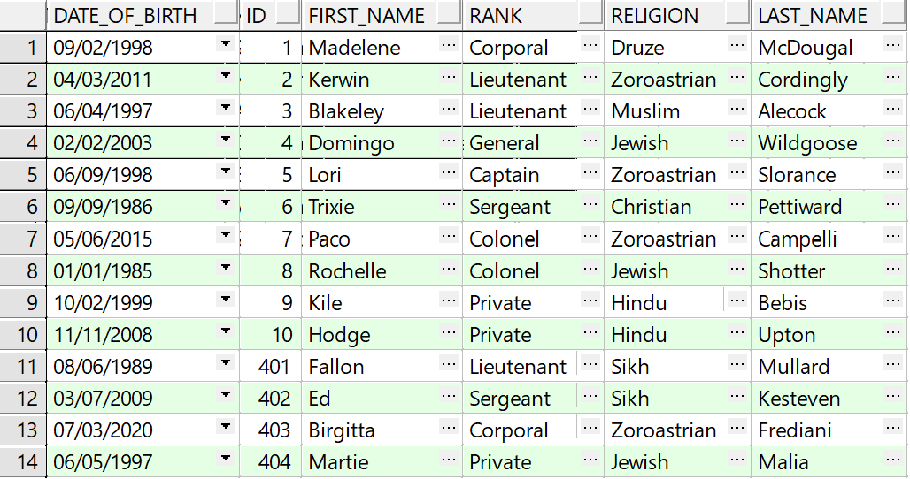

COMMANDER:

TEAM:

MILITARY RABBI:

COMBAT MEDIC:

OPERATION:

## שיטה 2 – python code

הקוד הבא יוצר קובץ insertTables.sql אשר בו פקודות insert של נתונים הנוצרים אקראית לכל טבלה:

import random  
import string  
import datetime  
  
# Define possible values for VARCHAR fields  
possible_values = {  
 'first_name': ['John', 'Jane', 'Alice', 'Bob', 'Charlie'],  
 'last_name': ['Smith', 'Doe', 'Johnson', 'Williams', 'Brown'],  
 'rank': ['Private', 'Sergeant', 'Lieutenant', 'Captain', 'Major'],  
 'religion': ['Christianity', 'Judaism', 'Islam', 'Hinduism', 'Buddhism'],  
 'nickname': ['Eagle', 'Tiger', 'Wolf', 'Bear', 'Lion'],  
 'sector': ['North', 'South', 'East', 'West', 'Central'],  
 'ethnicity': ['Caucasian', 'African American', 'Asian', 'Hispanic', 'Other'],  
 'qualification': ['Basic', 'Advanced', 'Expert'],  
 'location': ['Base A', 'Base B', 'Base C', 'Base D', 'Base E'],  
 'team_name': ['Alpha', 'Bravo', 'Charlie', 'Delta', 'Echo'],  
 'responsibility': ['sniper', 'scout', 'demolition expert', 'communications specialist', 'heavy gunner', 'engineer',  
 'reconnaissance', 'marksman', 'grenadier', 'sharpshooter']  
}  
  
  
def generate_random_string(length=10):  
 return ''.join(random.choices(string.ascii_letters + string.digits, k=length))  
  
  
def generate_date_help():  
 start_date = datetime.date(1980, 1, 1)  
 end_date = datetime.date(2000, 12, 31)  
 return start_date + (end_date - start_date) * random.random()  
  
  
def generate_date():  
 date = "DATE '" + generate_date_help().strftime("%Y-%m-%d") + "'"  
 return date  
  
  
def generate_sql_file(num_soldiers, num_commanders, num_teams, num_rabbis, num_medics, num_operations, num_soliders_in):  
 soldiers = []  
 commanders = []  
 teams = []  
 military_rabbis = []  
 combat_medics = []  
 operations = []  
 soliders_in = []  
  
 for i in range(1, num_soldiers + 1):  
 soldier = {  
 'date_of_birth': generate_date(),  
 'id': i,  
 'first_name': random.choice(possible_values['first_name']),  
 'rank': random.choice(possible_values['rank']),  
 'religion': random.choice(possible_values['religion']),  
 'last_name': random.choice(possible_values['last_name']),  
 'team_number': random.randint(1, num_teams)  
 }  
 soldiers.append(soldier)  
  
 for i in range(1, num_commanders + 1):  
 commander = {  
 'nickname': random.choice(possible_values['nickname']),  
 'soliders_affection': random.randint(1, 10),  
 'security_clearance': random.randint(1, 5),  
 'id': soldiers[i % num_soldiers]['id']  
 }  
 commanders.append(commander)  
  
 for i in range(1, num_teams + 1):  
 team = {  
 'team_number': i,  
 'name': random.choice(possible_values['team_name']),  
 'religious': random.randint(0, 1),  
 'commander_id': commanders[i % num_commanders]['id']  
 }  
 teams.append(team)  
  
 for i in range(1, num_rabbis + 1):  
 rabbi = {  
 'certified_Rabbi': random.randint(0, 1),  
 'Payytan': random.randint(0, 1),  
 'sector': random.choice(possible_values['sector']),  
 'ethnicity': random.choice(possible_values['ethnicity']),  
 'preacher': random.randint(0, 1),  
 'id': soldiers[i % num_soldiers]['id']  
 }  
 military_rabbis.append(rabbi)  
  
 for i in range(1, num_medics + 1):  
 medic = {  
 'qualification': random.choice(possible_values['qualification']),  
 'in_training': random.randint(0, 1),  
 'id': soldiers[i % num_soldiers]['id']  
 }  
 combat_medics.append(medic)  
  
 for i in range(1, num_operations + 1):  
 operation = {  
 'operation_date': generate_date(),  
 'location': random.choice(possible_values['location']),  
 'operation_id': i,  
 'commander_id': commanders[i % num_commanders]['id'],  
 'medic_id': combat_medics[i % num_medics]['id'],  
 'team_number': teams[i % num_teams]['team_number']  
 }  
 operations.append(operation)  
  
 for i in range(1, num_soliders_in + 1):  
 solider_in = {  
 'responsibility': random.choice(possible_values['responsibility']),  
 'id': soldiers[i % num_soldiers]['id'],  
 'team_number': teams[i % num_teams]['team_number']  
 }  
 soliders_in.append(solider_in)  
  
 # Create SQL file  
 with open('insertTables.sql', 'w') as f:  
 # Insert soldiers  
 for soldier in soldiers:  
 f.write(  
 f"INSERT INTO solider (date_of_birth, id, first_name, rank, religion, last_name) VALUES ({soldier['date_of_birth']}, {soldier['id']}, '{soldier['first_name']}', '{soldier['rank']}', '{soldier['religion']}', '{soldier['last_name']}');\n")  
  
 # Insert commanders  
 for commander in commanders:  
 f.write(  
 f"INSERT INTO commander (nickname, soliders_affection, security_clearance, id) VALUES ('{commander['nickname']}', {commander['soliders_affection']}, {commander['security_clearance']}, {commander['id']});\n")  
  
 # Insert teams  
 for team in teams:  
 f.write(  
 f"INSERT INTO team (team_number, name, religious, commander_id) VALUES ({team['team_number']}, '{team['name']}', {team['religious']}, {team['commander_id']});\n")  
  
 # Insert military rabbis  
 for rabbi in military_rabbis:  
 f.write(  
 f"INSERT INTO military_Rabbi (certified_Rabbi, Payytan, sector, ethnicity, preacher, id) VALUES ({rabbi['certified_Rabbi']}, {rabbi['Payytan']}, '{rabbi['sector']}', '{rabbi['ethnicity']}', {rabbi['preacher']}, {rabbi['id']});\n")  
  
 # Insert combat medics  
 for medic in combat_medics:  
 f.write(  
 f"INSERT INTO combat_medic (qualification, in_training, id) VALUES ('{medic['qualification']}', {medic['in_training']}, {medic['id']});\n")  
  
 # Insert operations  
 for operation in operations:  
 f.write(  
 f"INSERT INTO operation (operation_date, location, operation_id, commander_id, medic_id, team_number) VALUES ({operation['operation_date']}, '{operation['location']}', {operation['operation_id']}, {operation['commander_id']}, {operation['medic_id']}, {operation['team_number']});\n")  
  
 # Insert solider-team connections  
 for solider_in in soliders_in:  
 f.write(  
 f"INSERT INTO solider_in (responsibility, id, team_number) VALUES ('{solider_in['responsibility']}', '{solider_in['id']}', {solider_in['team_number']});\n")  
  
  
if __name__ == '__main__':  
 # Specify the number of entries for each table  
 num_soldiers = 1200  
 num_commanders = 400  
 num_teams = 400  
 num_rabbis = 400  
 num_medics = 400  
 num_operations = 400  
 num_soliders_in = 400  
  
 generate_sql_file(num_soldiers, num_commanders, num_teams, num_rabbis, num_medics, num_operations, num_soliders_in)

דוגמת קוד עבור כמות כניסות נמוכה:

INSERT INTO solider (date_of_birth, id, first_name, rank, religion, last_name) VALUES (DATE '1984-08-09', 1, 'Charlie', 'Lieutenant', 'Buddhism', 'Brown');

INSERT INTO solider (date_of_birth, id, first_name, rank, religion, last_name) VALUES (DATE '1996-08-28', 2, 'Bob', 'Sergeant', 'Buddhism', 'Doe');

INSERT INTO solider (date_of_birth, id, first_name, rank, religion, last_name) VALUES (DATE '1985-06-05', 3, 'John', 'Sergeant', 'Hinduism', 'Smith');

INSERT INTO solider (date_of_birth, id, first_name, rank, religion, last_name) VALUES (DATE '2000-07-01', 4, 'Bob', 'Lieutenant', 'Buddhism', 'Williams');

INSERT INTO solider (date_of_birth, id, first_name, rank, religion, last_name) VALUES (DATE '1988-06-05', 5, 'John', 'Captain', 'Judaism', 'Smith');

INSERT INTO solider (date_of_birth, id, first_name, rank, religion, last_name) VALUES (DATE '1985-05-15', 6, 'John', 'Captain', 'Hinduism', 'Johnson');

INSERT INTO solider (date_of_birth, id, first_name, rank, religion, last_name) VALUES (DATE '1989-08-25', 7, 'John', 'Sergeant', 'Judaism', 'Smith');

INSERT INTO solider (date_of_birth, id, first_name, rank, religion, last_name) VALUES (DATE '1988-12-07', 8, 'Alice', 'Sergeant', 'Islam', 'Brown');

INSERT INTO solider (date_of_birth, id, first_name, rank, religion, last_name) VALUES (DATE '1997-06-29', 9, 'Charlie', 'Captain', 'Judaism', 'Doe');

INSERT INTO solider (date_of_birth, id, first_name, rank, religion, last_name) VALUES (DATE '1993-05-26', 10, 'John', 'Private', 'Hinduism', 'Brown');

INSERT INTO solider (date_of_birth, id, first_name, rank, religion, last_name) VALUES (DATE '1983-04-05', 11, 'Alice', 'Private', 'Judaism', 'Brown');

INSERT INTO solider (date_of_birth, id, first_name, rank, religion, last_name) VALUES (DATE '1982-11-30', 12, 'Jane', 'Sergeant', 'Judaism', 'Williams');

INSERT INTO solider (date_of_birth, id, first_name, rank, religion, last_name) VALUES (DATE '1981-06-17', 13, 'Bob', 'Sergeant', 'Christianity', 'Brown');

INSERT INTO solider (date_of_birth, id, first_name, rank, religion, last_name) VALUES (DATE '1987-11-17', 14, 'John', 'Sergeant', 'Judaism', 'Smith');

INSERT INTO solider (date_of_birth, id, first_name, rank, religion, last_name) VALUES (DATE '1995-12-01', 15, 'Charlie', 'Private', 'Judaism', 'Smith');

INSERT INTO solider (date_of_birth, id, first_name, rank, religion, last_name) VALUES (DATE '1985-02-18', 16, 'Alice', 'Lieutenant', 'Islam', 'Williams');

INSERT INTO solider (date_of_birth, id, first_name, rank, religion, last_name) VALUES (DATE '1981-09-13', 17, 'John', 'Major', 'Judaism', 'Brown');

INSERT INTO solider (date_of_birth, id, first_name, rank, religion, last_name) VALUES (DATE '1986-12-31', 18, 'Jane', 'Private', 'Buddhism', 'Doe');

INSERT INTO solider (date_of_birth, id, first_name, rank, religion, last_name) VALUES (DATE '1987-06-29', 19, 'Charlie', 'Sergeant', 'Judaism', 'Johnson');

INSERT INTO solider (date_of_birth, id, first_name, rank, religion, last_name) VALUES (DATE '2000-12-23', 20, 'Charlie', 'Private', 'Hinduism', 'Williams');

INSERT INTO solider (date_of_birth, id, first_name, rank, religion, last_name) VALUES (DATE '1994-02-27', 21, 'Bob', 'Sergeant', 'Islam', 'Brown');

INSERT INTO solider (date_of_birth, id, first_name, rank, religion, last_name) VALUES (DATE '1992-11-17', 22, 'Jane', 'Sergeant', 'Islam', 'Brown');

INSERT INTO solider (date_of_birth, id, first_name, rank, religion, last_name) VALUES (DATE '1985-07-23', 23, 'Bob', 'Sergeant', 'Judaism', 'Brown');

INSERT INTO solider (date_of_birth, id, first_name, rank, religion, last_name) VALUES (DATE '1994-05-15', 24, 'Charlie', 'Captain', 'Christianity', 'Doe');

INSERT INTO solider (date_of_birth, id, first_name, rank, religion, last_name) VALUES (DATE '1997-12-26', 25, 'Charlie', 'Sergeant', 'Buddhism', 'Williams');

INSERT INTO solider (date_of_birth, id, first_name, rank, religion, last_name) VALUES (DATE '1985-09-11', 26, 'Bob', 'Private', 'Buddhism', 'Smith');

INSERT INTO solider (date_of_birth, id, first_name, rank, religion, last_name) VALUES (DATE '1995-06-09', 27, 'Alice', 'Captain', 'Judaism', 'Williams');

INSERT INTO solider (date_of_birth, id, first_name, rank, religion, last_name) VALUES (DATE '1987-01-08', 28, 'Bob', 'Lieutenant', 'Christianity', 'Johnson');

INSERT INTO solider (date_of_birth, id, first_name, rank, religion, last_name) VALUES (DATE '1982-05-24', 29, 'Charlie', 'Sergeant', 'Christianity', 'Smith');

INSERT INTO solider (date_of_birth, id, first_name, rank, religion, last_name) VALUES (DATE '1991-01-27', 30, 'Jane', 'Lieutenant', 'Islam', 'Williams');

INSERT INTO commander (nickname, soliders_affection, security_clearance, id) VALUES ('Eagle', 7, 2, 2);

INSERT INTO commander (nickname, soliders_affection, security_clearance, id) VALUES ('Bear', 7, 2, 3);

INSERT INTO commander (nickname, soliders_affection, security_clearance, id) VALUES ('Tiger', 3, 4, 4);

INSERT INTO commander (nickname, soliders_affection, security_clearance, id) VALUES ('Wolf', 10, 4, 5);

INSERT INTO commander (nickname, soliders_affection, security_clearance, id) VALUES ('Bear', 7, 5, 6);

INSERT INTO commander (nickname, soliders_affection, security_clearance, id) VALUES ('Bear', 6, 1, 7);

INSERT INTO commander (nickname, soliders_affection, security_clearance, id) VALUES ('Tiger', 9, 5, 8);

INSERT INTO commander (nickname, soliders_affection, security_clearance, id) VALUES ('Tiger', 9, 1, 9);

INSERT INTO commander (nickname, soliders_affection, security_clearance, id) VALUES ('Wolf', 8, 1, 10);

INSERT INTO commander (nickname, soliders_affection, security_clearance, id) VALUES ('Lion', 1, 1, 11);

INSERT INTO team (team_number, name, religious, commander_id) VALUES (1, 'Alpha', 0, 3);

INSERT INTO team (team_number, name, religious, commander_id) VALUES (2, 'Bravo', 1, 4);

INSERT INTO team (team_number, name, religious, commander_id) VALUES (3, 'Echo', 0, 5);

INSERT INTO team (team_number, name, religious, commander_id) VALUES (4, 'Echo', 0, 6);

INSERT INTO team (team_number, name, religious, commander_id) VALUES (5, 'Delta', 0, 7);

INSERT INTO team (team_number, name, religious, commander_id) VALUES (6, 'Charlie', 0, 8);

INSERT INTO team (team_number, name, religious, commander_id) VALUES (7, 'Charlie', 1, 9);

INSERT INTO team (team_number, name, religious, commander_id) VALUES (8, 'Bravo', 1, 10);

INSERT INTO team (team_number, name, religious, commander_id) VALUES (9, 'Bravo', 0, 11);

INSERT INTO team (team_number, name, religious, commander_id) VALUES (10, 'Echo', 1, 2);

INSERT INTO military_Rabbi (certified_Rabbi, Payytan, sector, ethnicity, preacher, id) VALUES (1, 0, 'South', 'African American', 0, 2);

INSERT INTO military_Rabbi (certified_Rabbi, Payytan, sector, ethnicity, preacher, id) VALUES (1, 0, 'Central', 'Asian', 1, 3);

INSERT INTO military_Rabbi (certified_Rabbi, Payytan, sector, ethnicity, preacher, id) VALUES (0, 0, 'East', 'Other', 0, 4);

INSERT INTO military_Rabbi (certified_Rabbi, Payytan, sector, ethnicity, preacher, id) VALUES (0, 1, 'West', 'African American', 1, 5);

INSERT INTO military_Rabbi (certified_Rabbi, Payytan, sector, ethnicity, preacher, id) VALUES (0, 1, 'West', 'Hispanic', 0, 6);

INSERT INTO military_Rabbi (certified_Rabbi, Payytan, sector, ethnicity, preacher, id) VALUES (0, 0, 'South', 'Caucasian', 1, 7);

INSERT INTO military_Rabbi (certified_Rabbi, Payytan, sector, ethnicity, preacher, id) VALUES (0, 0, 'West', 'African American', 1, 8);

INSERT INTO military_Rabbi (certified_Rabbi, Payytan, sector, ethnicity, preacher, id) VALUES (1, 0, 'West', 'Caucasian', 0, 9);

INSERT INTO military_Rabbi (certified_Rabbi, Payytan, sector, ethnicity, preacher, id) VALUES (1, 1, 'South', 'Caucasian', 1, 10);

INSERT INTO military_Rabbi (certified_Rabbi, Payytan, sector, ethnicity, preacher, id) VALUES (0, 0, 'East', 'Hispanic', 0, 11);

INSERT INTO combat_medic (qualification, in_training, id) VALUES ('Expert', 0, 2);

INSERT INTO combat_medic (qualification, in_training, id) VALUES ('Basic', 0, 3);

INSERT INTO combat_medic (qualification, in_training, id) VALUES ('Advanced', 0, 4);

INSERT INTO combat_medic (qualification, in_training, id) VALUES ('Basic', 0, 5);

INSERT INTO combat_medic (qualification, in_training, id) VALUES ('Basic', 1, 6);

INSERT INTO combat_medic (qualification, in_training, id) VALUES ('Expert', 0, 7);

INSERT INTO combat_medic (qualification, in_training, id) VALUES ('Advanced', 1, 8);

INSERT INTO combat_medic (qualification, in_training, id) VALUES ('Advanced', 0, 9);

INSERT INTO combat_medic (qualification, in_training, id) VALUES ('Expert', 1, 10);

INSERT INTO combat_medic (qualification, in_training, id) VALUES ('Expert', 1, 11);

INSERT INTO operation (operation_date, location, operation_id, commander_id, medic_id, team_number) VALUES (DATE '1981-09-30', 'Base B', 1, 3, 3, 2);

INSERT INTO operation (operation_date, location, operation_id, commander_id, medic_id, team_number) VALUES (DATE '1992-12-17', 'Base C', 2, 4, 4, 3);

INSERT INTO operation (operation_date, location, operation_id, commander_id, medic_id, team_number) VALUES (DATE '1995-10-24', 'Base B', 3, 5, 5, 4);

INSERT INTO operation (operation_date, location, operation_id, commander_id, medic_id, team_number) VALUES (DATE '1995-09-16', 'Base E', 4, 6, 6, 5);

INSERT INTO operation (operation_date, location, operation_id, commander_id, medic_id, team_number) VALUES (DATE '1993-03-17', 'Base B', 5, 7, 7, 6);

INSERT INTO operation (operation_date, location, operation_id, commander_id, medic_id, team_number) VALUES (DATE '1987-01-11', 'Base E', 6, 8, 8, 7);

INSERT INTO operation (operation_date, location, operation_id, commander_id, medic_id, team_number) VALUES (DATE '1985-11-18', 'Base A', 7, 9, 9, 8);

INSERT INTO operation (operation_date, location, operation_id, commander_id, medic_id, team_number) VALUES (DATE '1992-08-29', 'Base C', 8, 10, 10, 9);

INSERT INTO operation (operation_date, location, operation_id, commander_id, medic_id, team_number) VALUES (DATE '2000-05-30', 'Base B', 9, 11, 11, 10);

INSERT INTO operation (operation_date, location, operation_id, commander_id, medic_id, team_number) VALUES (DATE '1992-11-19', 'Base B', 10, 2, 2, 1);

INSERT INTO solider_in (responsibility, id, team_number) VALUES ('scout', '2', 2);

INSERT INTO solider_in (responsibility, id, team_number) VALUES ('marksman', '3', 3);

INSERT INTO solider_in (responsibility, id, team_number) VALUES ('sharpshooter', '4', 4);

INSERT INTO solider_in (responsibility, id, team_number) VALUES ('engineer', '5', 5);

INSERT INTO solider_in (responsibility, id, team_number) VALUES ('scout', '6', 6);

INSERT INTO solider_in (responsibility, id, team_number) VALUES ('scout', '7', 7);

INSERT INTO solider_in (responsibility, id, team_number) VALUES ('reconnaissance', '8', 8);

INSERT INTO solider_in (responsibility, id, team_number) VALUES ('engineer', '9', 9);

INSERT INTO solider_in (responsibility, id, team_number) VALUES ('sharpshooter', '10', 10);

INSERT INTO solider_in (responsibility, id, team_number) VALUES ('demolition expert', '11', 1);

commit;

והתוצאה לאחר select all:

SOLIDER-IN:  
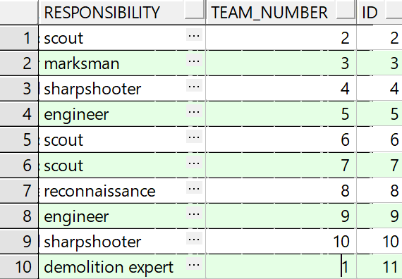

SOLIDER:

COMMANDER:

TEAM:

MILITARY RABBI:

COMBAT MEDIC:

OPERATION:

## שיטה 3 – data generator (PLSQL developer)

בשיטה זו אנו משתמשים ב-data generator המובנה של PLSQL developer.

Solider:  
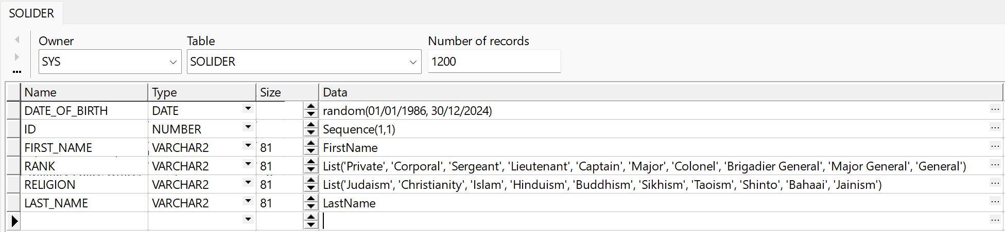

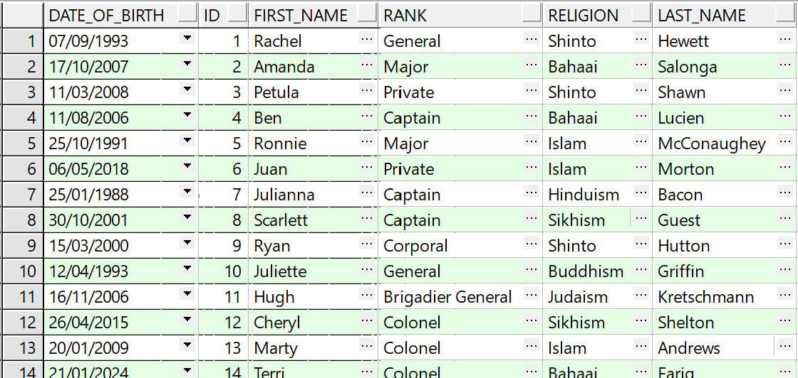

Commander:  
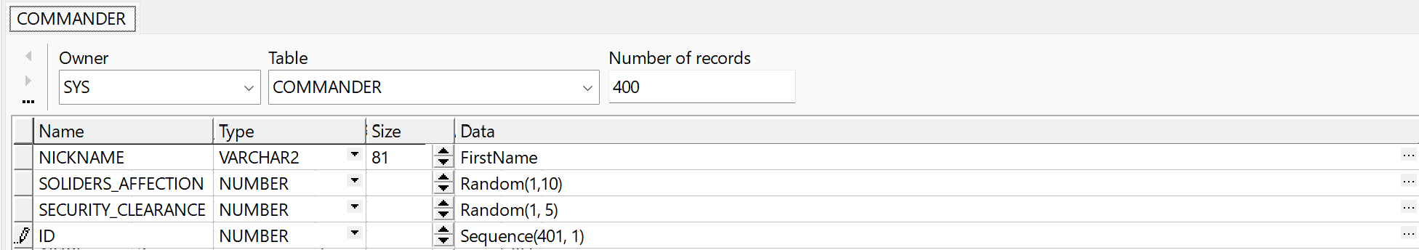

Combat medic:  
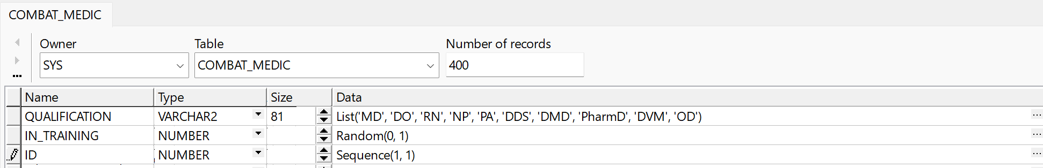

Military rabbi:

Team:  
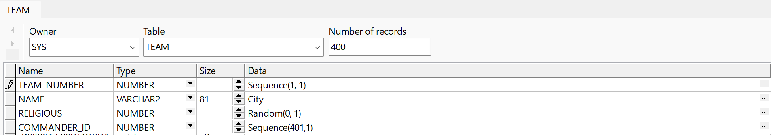

Operation:  
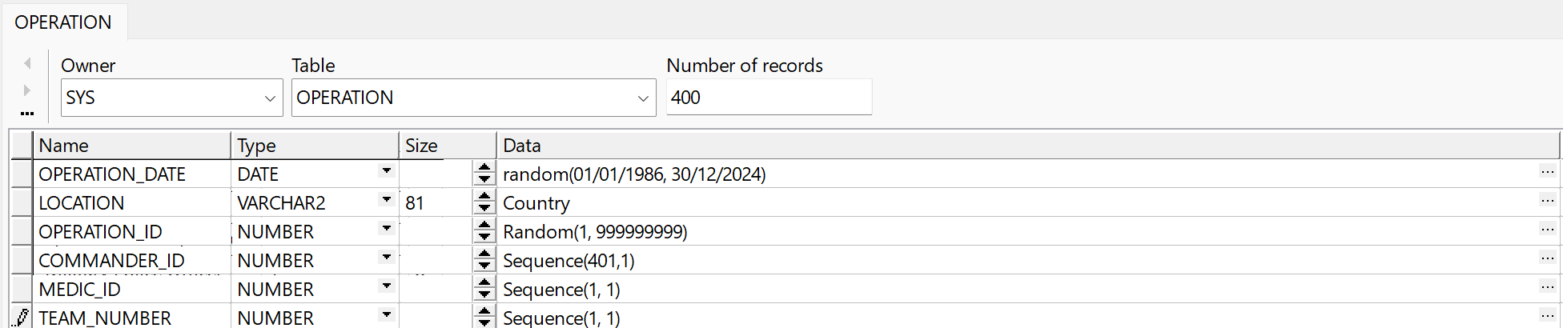

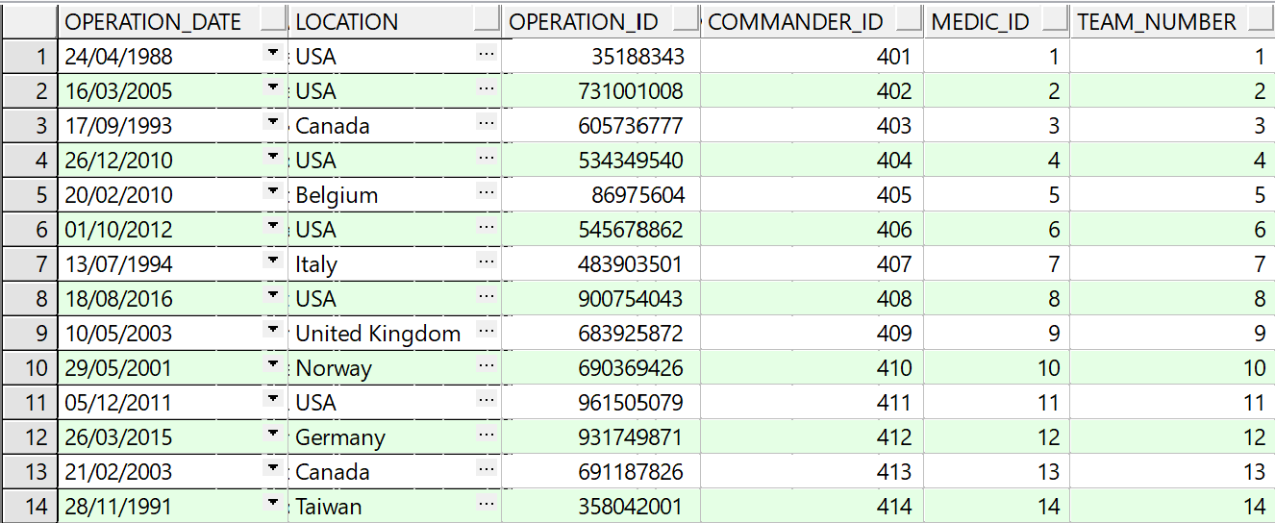

Solider_in:

# גיבוי נתונים

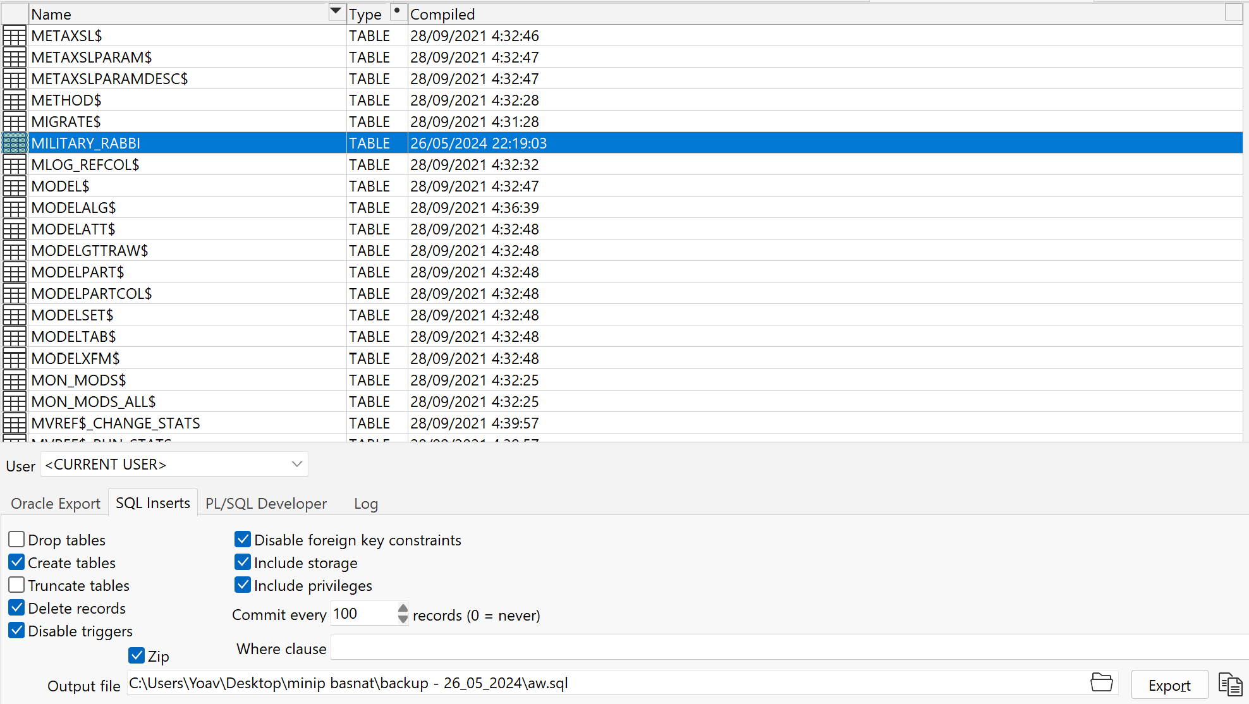

The backup can be found in the GitHub of the project.

# שחזור נתונים מגיבוי

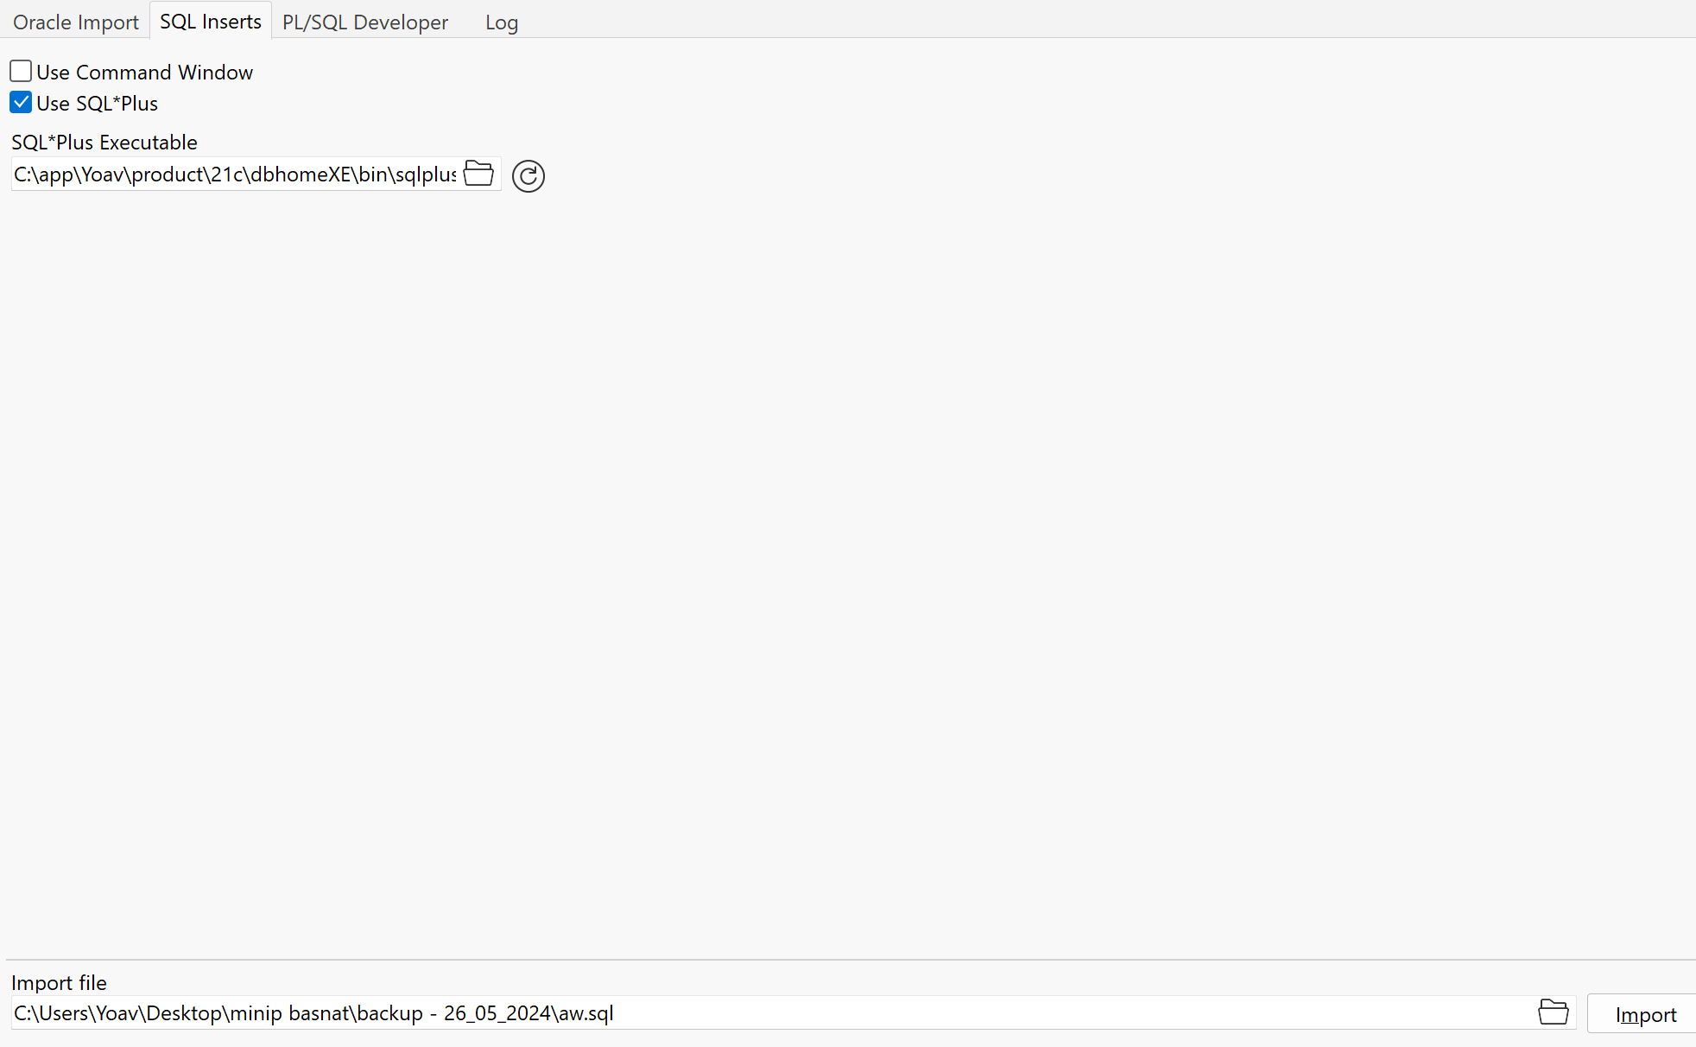

ובמבחן התוצאה:

